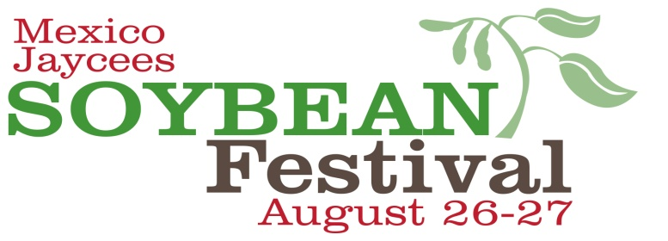

SPONSORSHIPS LEVELS

**LEVEL Platinum Gold Silver Bronze**

**$1,250 $1,000 $500 $250**

Web Ads YES YES YES YES

Free Vendor Booth YES YES YES YES

Logo on T-Shirt YES NO NO NO

Name on T-Shirt Logo YES (L) YES (M) NO

2 Free Event T-Shirts YES YES NO NO

Print Ads YES YES NO NO

Name on Cups YES YES NO NO

Radio Ads YES NO NO NO

Hole Sponsorship Included Included Included Included

Golf Team Included Included $200 $300

**Proceeds from the Soybean Festival benefit local non-profit organizations**

**and the Mexico Jaycees Scholarship Fund.**

**Event Details @** [**www.mexicosoybean.com**](http://www.mexicosoybean.com)

Please mail payment and logos to the Mexico Jaycees, P.O. Box 341, Mexico, MO 65265 by July 1st. Logos can also be emailed to [mexicomojaycees@gmail.com](mailto:mexicomojaycees@gmail.com), logos must be received by July 1st. Any questions please contact Josh Hanley at 473-3002 or Daniel Norman at 253-0063

**----------------------------------------------------------------------------------------------------------**

**j0293070 Mexico Jaycees Golf Tournament j0293070**

**Sat. October 8th, 2016**

**Arthur Hills 18 Hole Golf Course**

Team Sponsorship $350

Hole Sponsorships $125

**Business Name: Total:­_______________________**