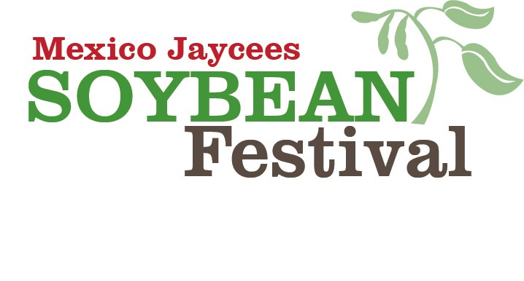
August 27th - 28th, 2021

SPONSORSHIPS LEVELS

LEVEL |  | Platinum | Gold | Silver | Bronze
 |  | $1,250 | $1,000 | $500 | $250
Web Ads |  | YES | YES | YES | YES
Free Vendor Booth |  | YES | YES | YES | YES
Print Ads |  | YES | YES | YES | NO
Name on Cups |  | YES | YES | NO | NO
Radio Ads |  | YES | NO | NO | NO

All items subject to change if necessary due to Covid.

Proceeds from the Soybean Festival benefit local non-profit organizations and the Mexico Jaycees Scholarship Fund.
Event Details @ www.mexicosoybean.org
Please mail payment and logos to the Mexico Jaycees, P.O. Box 341, Mexico, MO 65265 by July 16th. Logos can also be emailed to mexicomojaycees@gmail.com, logos must be received by July 16th.
Any questions please contact Marissa Lightsey (573) 721-8232 or Josh Frantz (573) 721-7066.

Business Name: Total: _

